**Practical Task 1**

**JOB SEEKERS**

1. Find 5 junior tech roles currently being advertised

Role 1 - Large company (1000+ employees)

* URL: <https://www.squarepoint-capital.com/open-opportunities#/job/4481896>
* Job title: Junior Quant Researcher - Data Science
* Company: Squarepoint Capital
* Company size: 1,001-5,000 employees
* Location: London
* Hiring Person: Jack French
  + LinkedIn: [linkedin.com/in/jack-french-7270a9136](https://www.linkedin.com/in/jack-french-7270a9136)

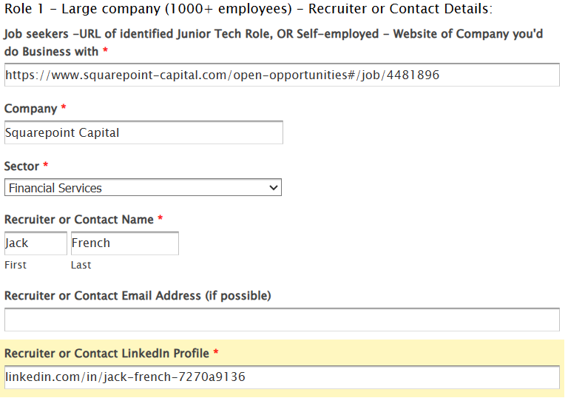

Role 2 - Small Company (500-1000 employees)

* URL: <https://apply.workable.com/quantexa/j/70A65052C6/>
* Job title: Data Engineer
* Company: Quantexa
* Company size: 501-1,000 employees
* Location: London
* Hiring Person: Richard Stern
  + LinkedIn: <https://www.linkedin.com/in/richard-stern-98710765/>

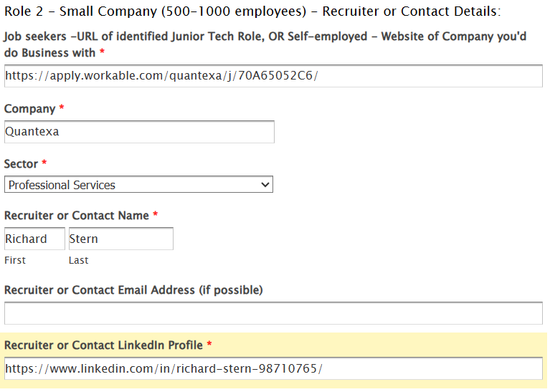

Role 3 - Tech Scale-up (up to 100 employees)

* URL: <https://www.tenokonda.com/about_us/careers>
* Job title: Quantitative R&D
* Company: Tenokonda
* Company size:
* Location: Remote (UK)
* Hiring Person: Adrien Papaioannou
  + e-mail: info@tenokonda.com
  + LinkedIn: <https://www.linkedin.com/in/adrienpapaioannou/>

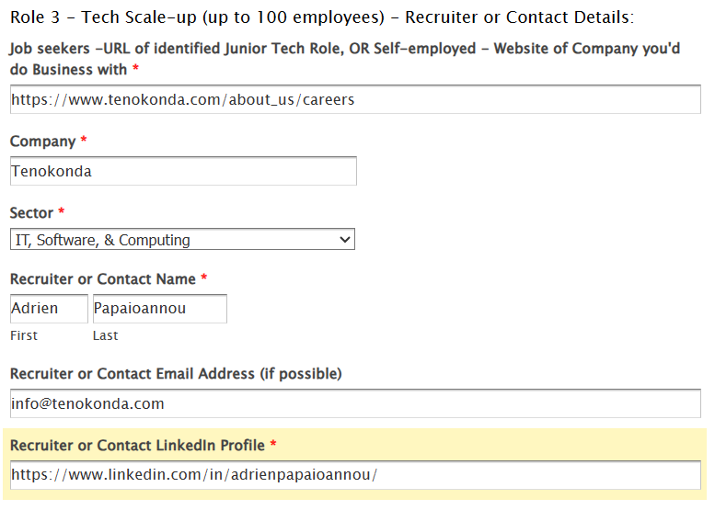

Role 4 - Paid internship or Apprenticeship

* URL: <https://www.gresearch.com/role/R2275-Internship-in-Quantitative-Research/>
* Job title: Internship in Quantitative Research
* Company: G-Research
* Company size: 501-1,000 employees
* Location: London, UK
* Hiring Person: Olivia Bateman
  + e-mail: Oliva.Bateman@gresearch.co.uk
  + LinkedIn: <https://www.linkedin.com/in/olivabateman>

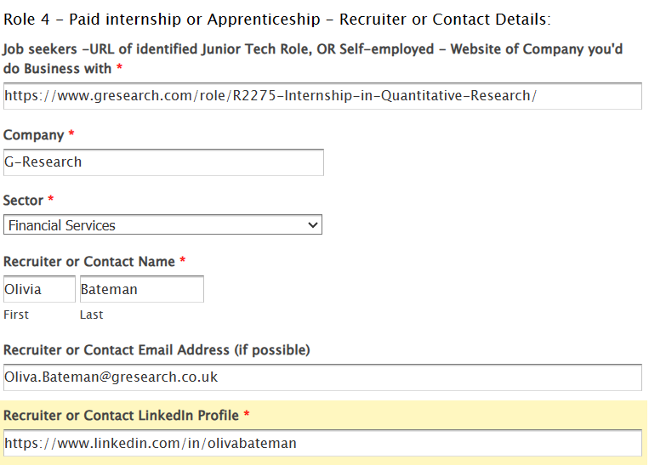

Role 5 - Hire-to-Train, Recruitment Agency Role, or Any Other Company Type

* URL: <https://www.linkedin.com/jobs/view/3794007762>
* Job title: Data Scientist
* Company: Opus Recruitment Solutions
* Company size: 201-500 employees
* Location: London, Hybrid
* Hiring Person: Tom Hannah
  + LinkedIn: <https://www.linkedin.com/in/tom-hannah-709676145/>

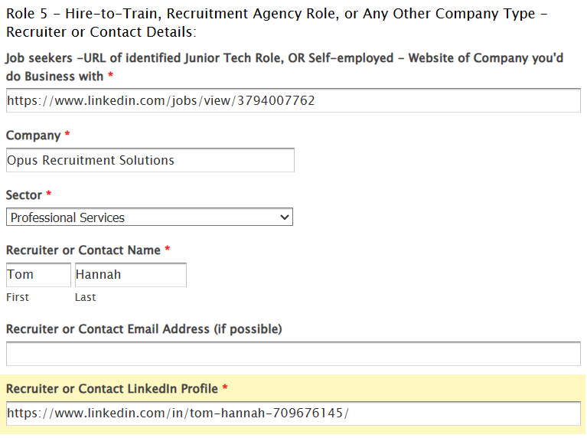

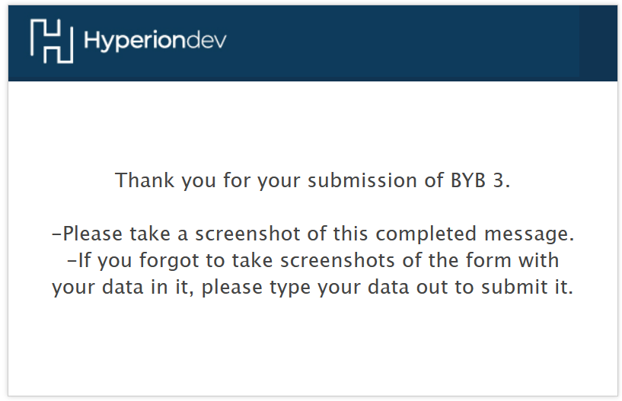

2. My tracker spreadsheet (Job/Interview/Pitch Opportunities): <https://docs.google.com/spreadsheets/d/12TX9iYbzYEnn4uMH0XC7RVWj6YGCPJVm0QRKc4j-L4I/edit?usp=sharing>

3. My hackajob profile:

